OverView

Website of Vietnam Maritime University (VMU) was built a long time ago around the beginning of the 21st century. The website was built with the aim of creating a close connection between the school, students and society. Thereby promoting the school's activities, creating a playground and learning for students. Besides, VMU's website is maintained with content and form activities that are always improved and innovated. The website has also provided the students with important information, announcements and career guidance for them right from the time they were in school. For parents, this system has helped them quickly update the school's guidelines and policies, information related to learning and training of students, creating publicity and transparency in the process of operation. school.

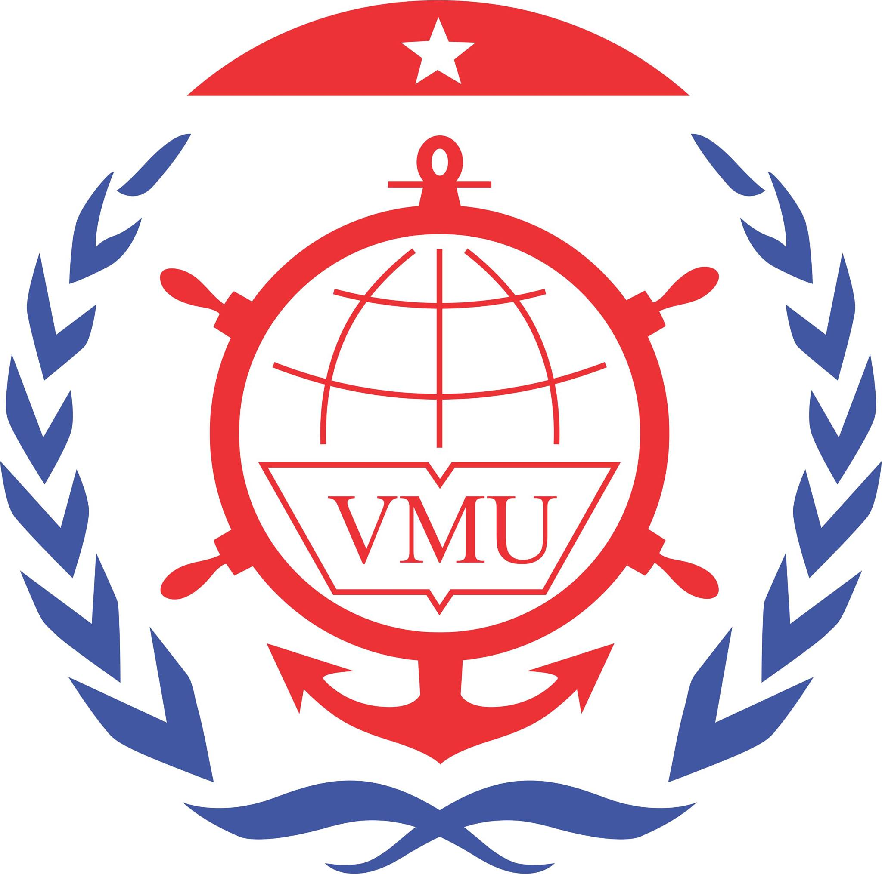

However, today with the trend of information technology, the development of digital transformation requires the digitalization scale to be upgraded with more operations. Especially in the context of covid 19, the online website needs to be upgraded even more. Therefore, the current model of VMU has appeared many limitations with the increasingly developed model of the university as well as not keeping up with the development of technology.

Therefore, in the 4.0 era, digital transformation is one of the important and concerned issues of an educational institution. Specifically, many universities now have a website system that provides all relevant services in management, administration, teaching, learning, life, cooperation and information... for all subjects. stakeholders include staff, lecturers, students, parents, alumni and partners. Basic messages such as integrating many tasks such as: registration of subjects, electronic student management, teacher's teaching schedule, .... Meanwhile, the Vietnam Maritime University still uses the direct application mechanism for these tasks.

Especially in the current global pandemic, doing everything in a direct way is very difficult. Therefore, everything needs to be changed and improved to adapt to this situation. 

* Realizing that urgency, in this report, we offer solutions to improve the system scale of Vietnam Maritime University in the direction of more convenience, better user support, and superiority. contribute to improving the quality of training in the 4.0 period

Solution: